Ideation Phase
Brainstorm & Idea Prioritization Template

Date | 08 DECEMBER 2025
Team ID (SkillWallet ID) | SWUID202560126
Project Name | Book a Doctor
Maximum Marks | 4 Marks

Brainstorm & Idea Prioritization
Step-1: Team Gathering, Collaboration and Select the Problem Statement
Primary Problem Statement:
Patients struggle to find trusted doctors and book appointments efficiently because traditional systems are manual, confusing, and unreliable — leading to long waiting times, missed appointments, and frustration for both patients and healthcare providers.

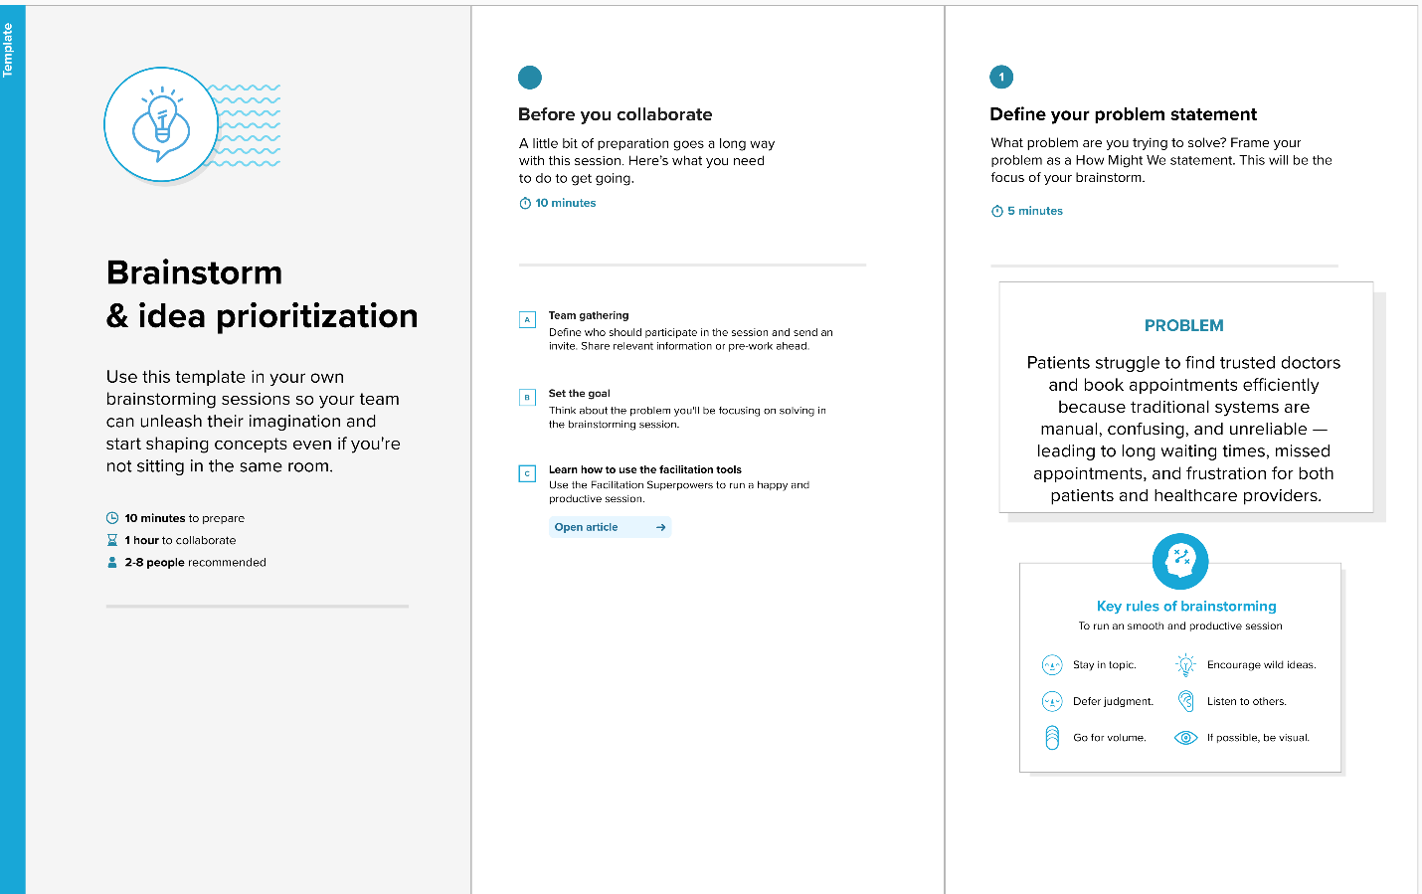

Step-2: Brainstorm, Idea Listing and Grouping
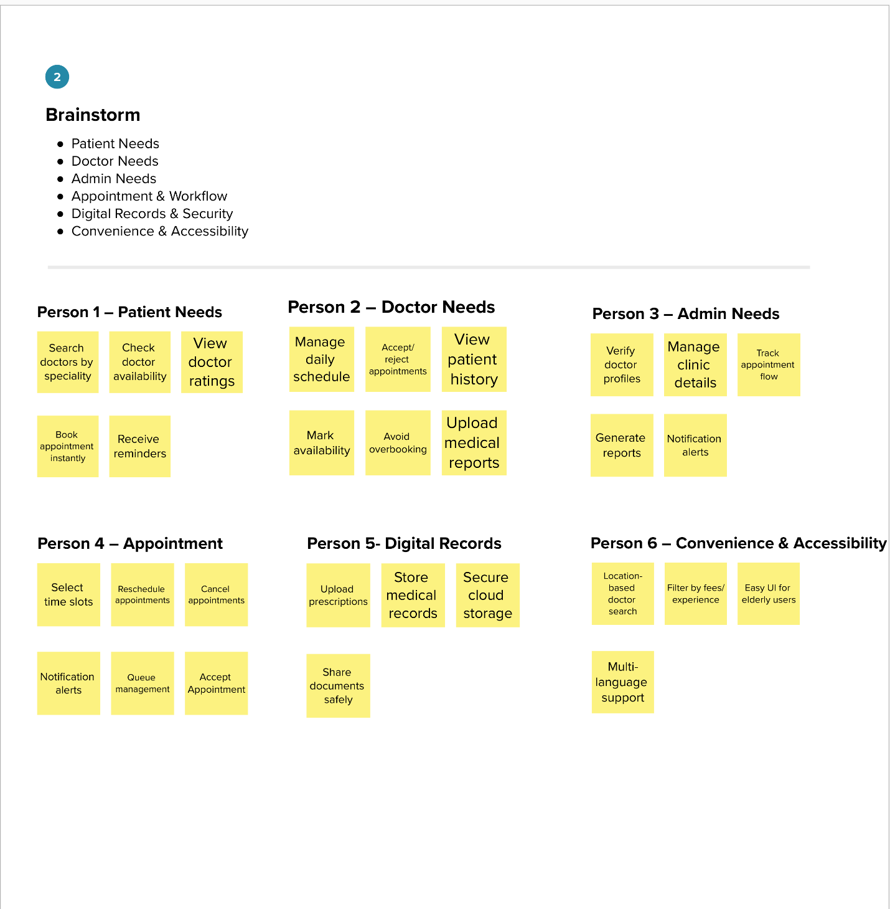

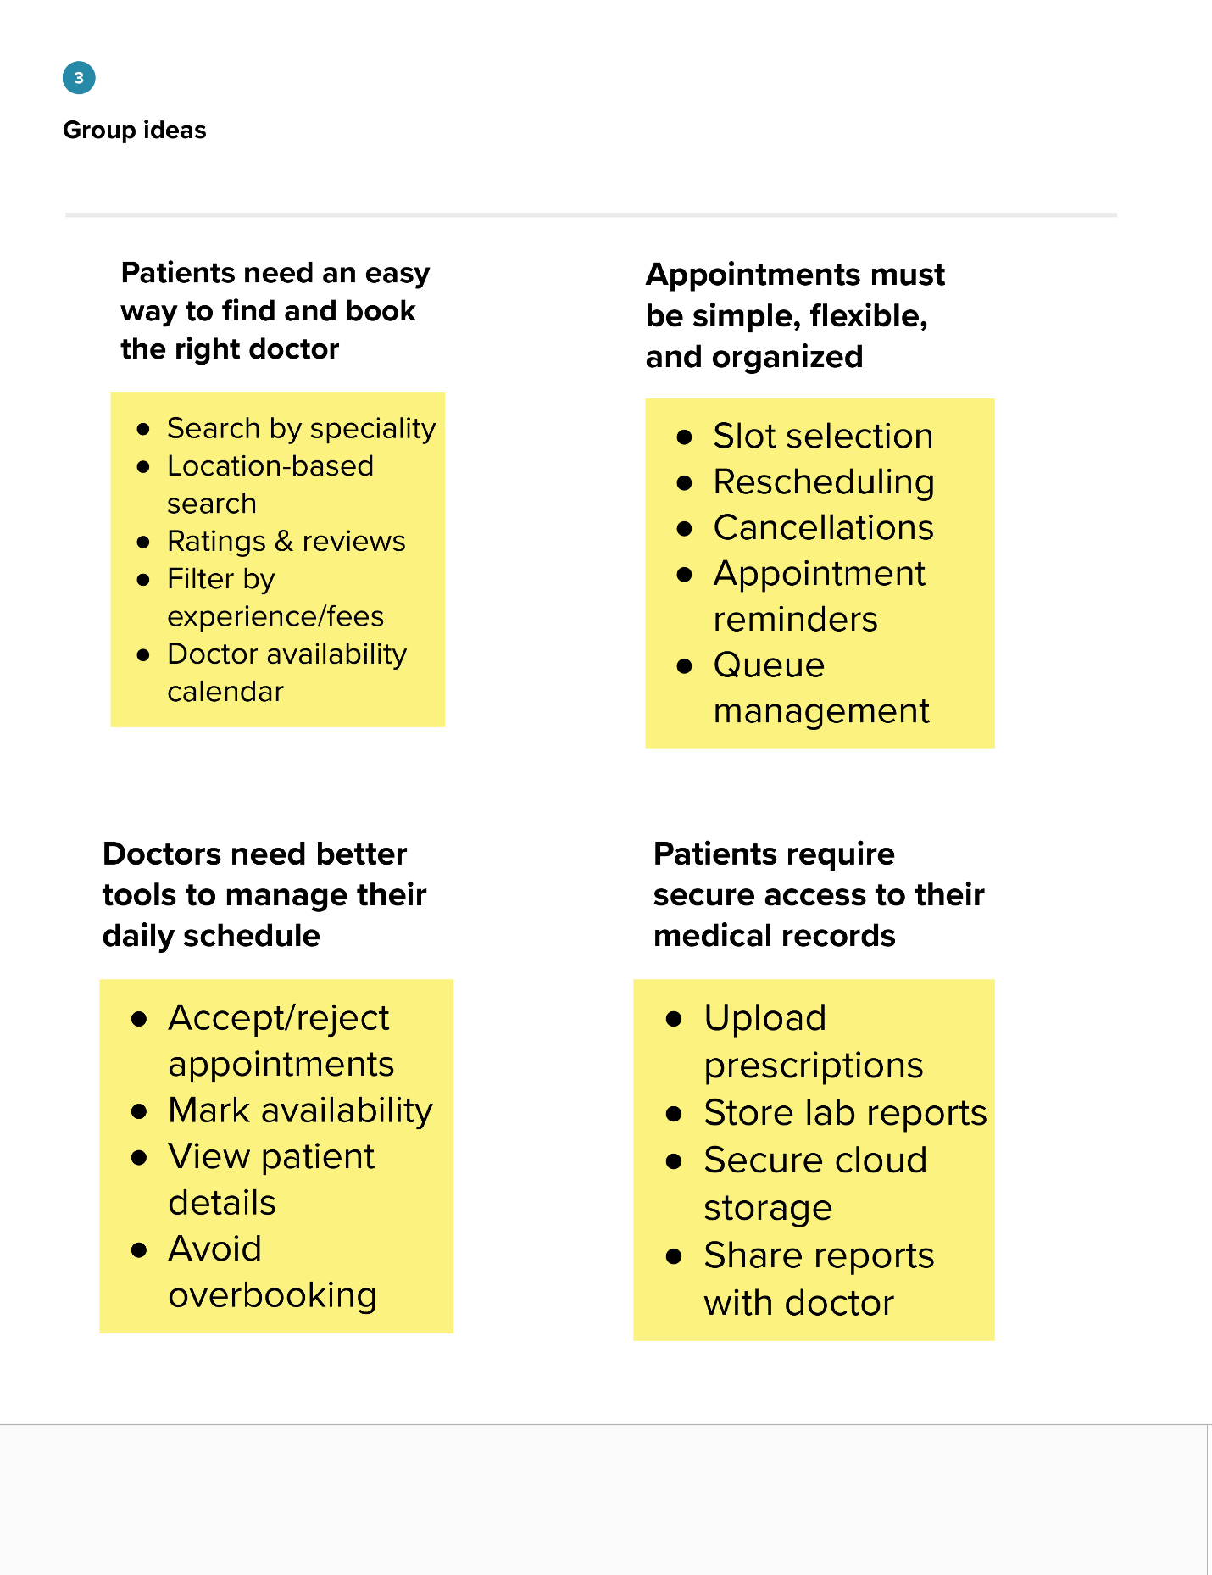
Step-3: Idea Prioritization
